Adverbs Modify

🔹 What Is Adverbs Modify?
# Source: AI Source: Provided by: [Data Path: Persons Table -> ID Column: 1, Name_En Column: Motasem Essam] -> From: [Chatgpt (GPT‑5 Mini)] on [8/7/2025]
An adverb is a type of modifier that modifies or describes a verb, adjective, another adverb, or even an entire sentence. It adds information about how, when, where, to what extent, or under what condition something happens.

🔸 What Can Adverbs Modify?
# Source: AI Source: Provided by: [Data Path: Persons Table -> ID Column: 1, Name_En Column: Motasem Essam] -> From: [Chatgpt (GPT‑5 Mini)] on [8/7/2025]
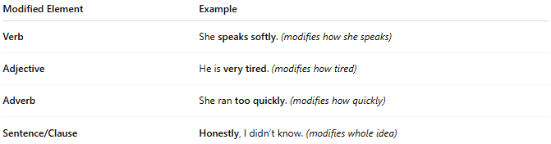
Modified Element | Example
Verb | She speaks softly. (modifies how she speaks)
Adjective | He is very tired. (modifies how tired)
Adverb | She ran too quickly. (modifies how quickly)
Sentence/Clause | Honestly, I didn’t know. (modifies whole idea)

🔸 Common Questions Adverbs Answer:
# Source: AI Source: Provided by: [Data Path: Persons Table -> ID Column: 1, Name_En Column: Motasem Essam] -> From: [Chatgpt (GPT‑5 Mini)] on [8/7/2025]
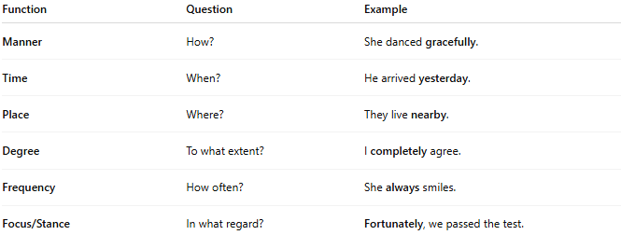
Function | Question | Example
Manner | How? | She danced gracefully.
Time | When? | He arrived yesterday.
Place | Where? | They live nearby.
Degree | To what extent? | I completely agree.
Frequency | How often? | She always smiles.
Focus/Stance | In what regard? | Fortunately, we passed the test.

🔸 Examples of Adverbs as Modifiers:
# Source: AI Source: Provided by: [Data Path: Persons Table -> ID Column: 1, Name_En Column: Motasem Essam] -> From: [Chatgpt (GPT‑5 Mini)] on [8/7/2025]
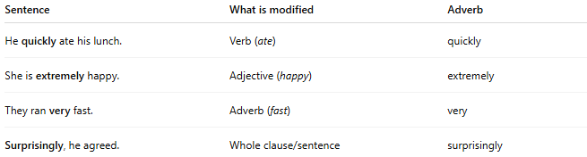
Sentence | What is modified | Adverb
He quickly ate his lunch. | Verb (ate) | quickly
She is extremely happy. | Adjective (happy) | extremely
They ran very fast. | Adverb (fast) | very
Surprisingly, he agreed. | Whole clause/sentence | surprisingly

